**FOOP201 Lab Sheet – Week 5**

**Classes/Objects**

**Exercise 1**

Create a class called BankAccount which contains properties for the account number, balance, and overdraft limit. Add a constructor which takes account number and overdraft limit as parameters. The balance should be initialised to 0. Add a PrintDetails method to BankAccount which prints all data about the bank account to the console. Create two bank account objects and print their details using this method. Add a method Deposit which deposits money to account. Add a method Withdraw which withdraws money checking that there are sufficient funds. Add some code to deposit money and then withdraw.

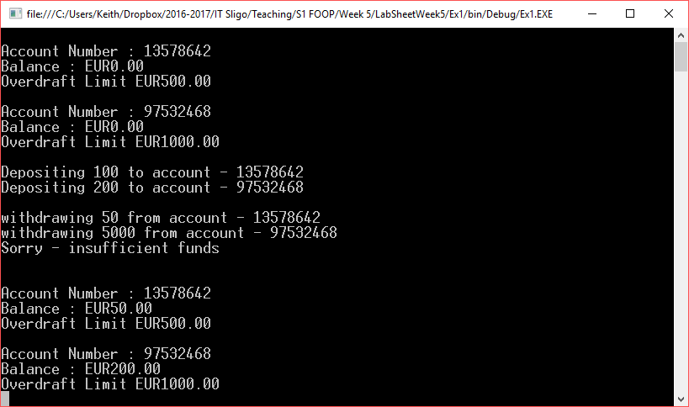

**Exercise 2**

Shapes. This program calculates the area of 3 shapes - a circle, rectangle and cylinder. The values are hard coded in but you could expand the program to get user input. Use Math.Pow(value, power), Math.PI. Initially create the program with hardcoded values. Once this is working amend this to take user input.

|  |  |  |
| --- | --- | --- |
| **Circle** | **Rectangle**  Length x Width | **Cylinder** |

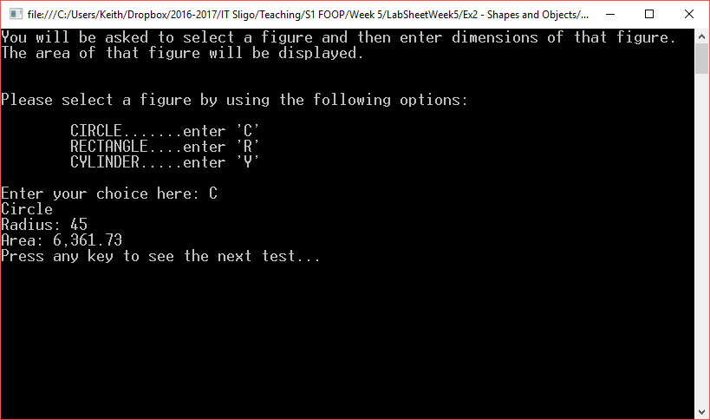

**Exercise 3**

Pay. This application calculates the deductions and take home pay for an employee. An employee class is used with the main program. The deduction rates are Tax 18%, Retirement Contribution 10%, and Social Security 6%. If an employee is hourly paid and works more than 40 hours a rate of 1.5 applied to the overtime hours. The user is asked to enter details for an employee and the results are displayed as shown below. Properties and methods are also shown below

|  |  |
| --- | --- |
| Properties | Methods |
|  |  |

